MOBILE DETECTOR CIRCUIT

# B.Tech. Lab Project Report on

**Analog and Digital Communication (19EC2105)**

**Submitted By :**

**Name : Id no :**

B.Raghuram 190040067

P.Suseelkousic 190040415

UNDER THE ESTEEMED GUIDANCE

OF

<**KS.Ramesh** sir>

**<Professor>**



**DEPARTMENT OF ELECTRONICS & COMMUNICATION ENGINEERING**

**KONERU LAKSHMIAH EDUCATION FOUNDATION VADDESWARAM, GUNTUR**

## NOVEMBER, 2020



**CERTIFICATE**

I hereby certify that the work which is being presented in the B.Tech. Project Report entitled **“MOBILE DETECTOR CIRCUIT”** in partial fulfillment of the requirements for the award of the **Bachelor of Technology in ELECTRONICS AND COMMUNICATION** and submitted to the Department of Analogs and Digital Communication of KLEF, Vaddeswaram, Guntur . It is an authentic record of our own work carried out during the period from August 2020 to November 2020 under the supervision of **KS.Ramesh sir, Professor for Analog and Digital Communication (sec-1), ECE Department**.

Signature of Candidates :

B.Raghuram 190040067

P.SuseelKousic 190040415

**INDEX**

* **Abstract**
* **Introduction**
* **Circuit diagram and components**
* **Applications and real time use**
* **Conclusion**

**Abstract:**

Usage of mobile phones has been a big issue in exams halls and other confidential areas so to reduce these issues we will be preparing a mobile signal detector which can be used to detect any transmission of data through signals. This can be done in a quite easily mannar.

**INTRODUCTION :**

* Prohibition of mobile phones has been increased a lot lately in schools, colleges and even examination centers. So the basic solution is using a mobile detector.
* Mobile detectors are simple circuit which can detect mobile phone signals.
* The reason for this increased interest is largely due to disturbance, as well as wrong and inappropriate usage of mobile phones by the users alike.
* There is need for the detection of mobile phone signals in areas where it is prohibited.
* Mobile phones uses RF with a wavelength of 30cm at 872 to 2170 MHz that is, the signal is high frequency with huge energy.
* When the mobile phone is active, it transmits the signal in the form of sine wave which passes through the space in the form of EM waves.
* The encoded audio/video signal contains electromagnetic radiation which is picked up by the receiver in the base station.

Working Principle of Mobile Detector Circuit :

* The **basic principle** behind the **Cell Phone Detector circuit** is to **detect** the RF Signals.
* In the Mobile Detector Circuit, In this project we will design and develop a digital signal detector which is capable of detecting incoming and outgoing signals from mobile phones.
* The presence of an activated mobile phone can be detected by this handy, pocket-size mobile signal detector from a distance of 70-80cm, which could be used in preventing the use of mobile phones in examination halls, confidential rooms etc.
* The circuit can detect the incoming and outing calls, text messages, even if the mobile is kept in the silent mode.
* The moment the gadget detects Radio Frequency (RF) transmission signal from an activated mobile phone, it starts sounding a beep alarm and the Light Emitting Diode (LED) blinks.
* The alarm continues until the signal transmission ceases. The circuit is assembled on a general purpose PCB and breadboard as compact as possible .

**Real-life Applications :**

* Can be used in the exam halls, class rooms.
* Can be used in confidential meetings, and conference halls

**CIRCUIT DIAGRAM :** 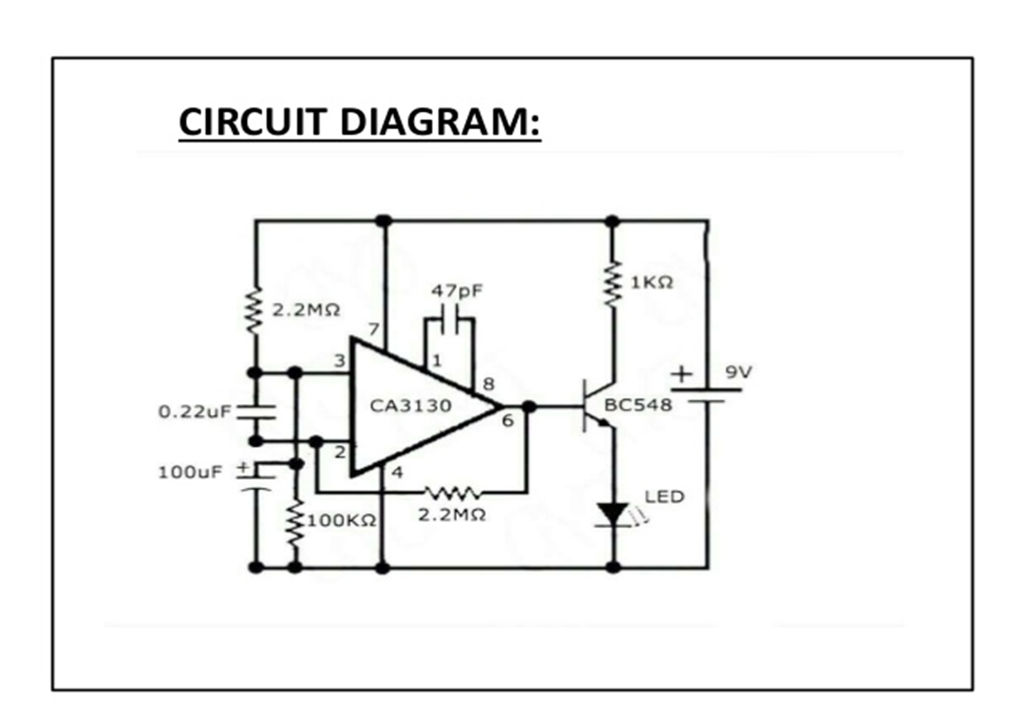

**MOBILE DETECTION CIRCUIT HARDWARE IMPLEMENTATION PICS :**

**Fig 1 :**

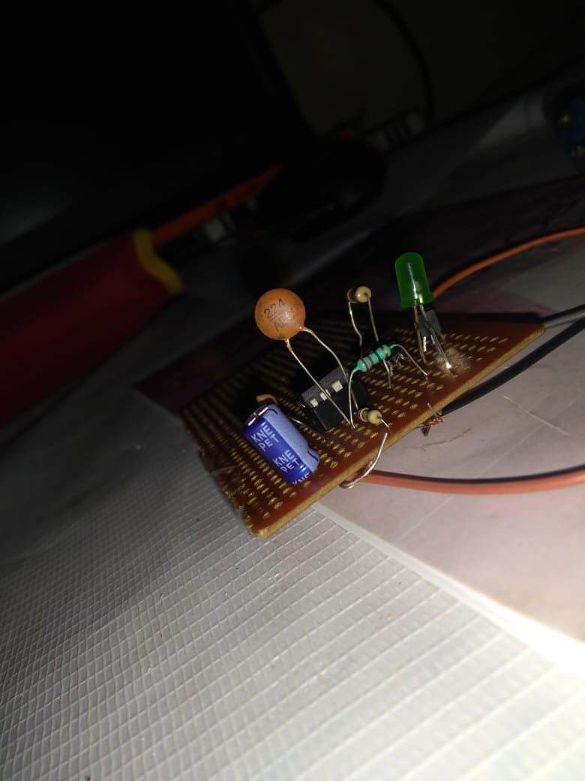

**Fig 2:**

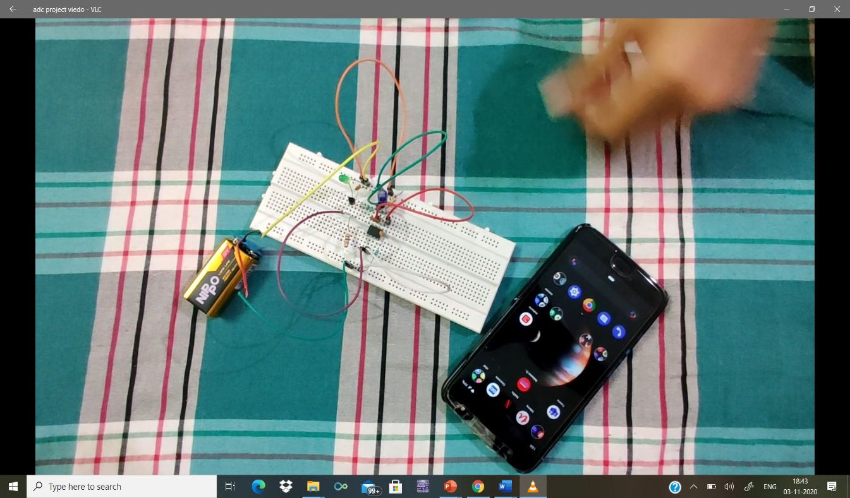

**Fig 3 :**

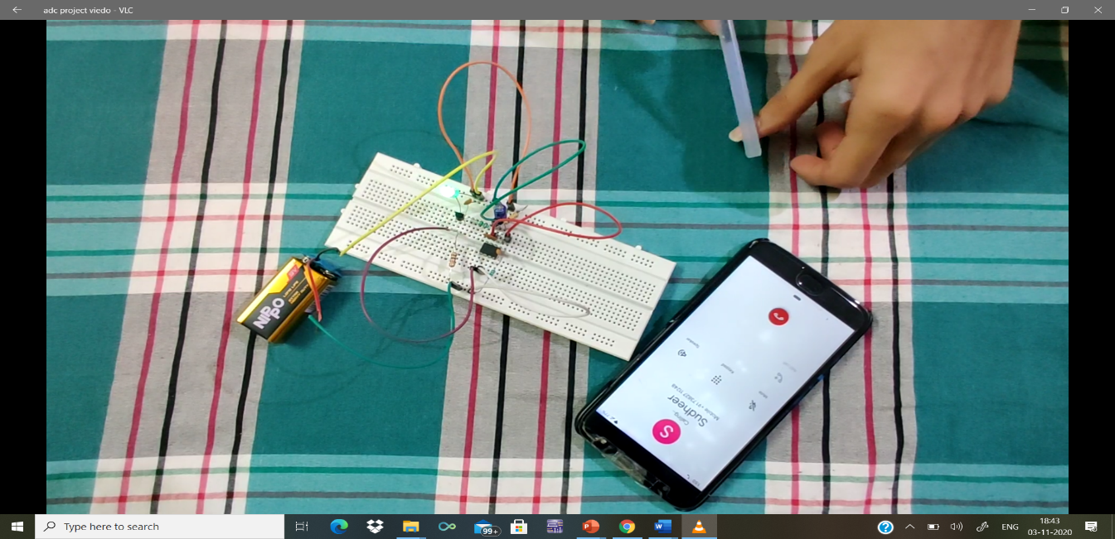

**Fig 4 :**

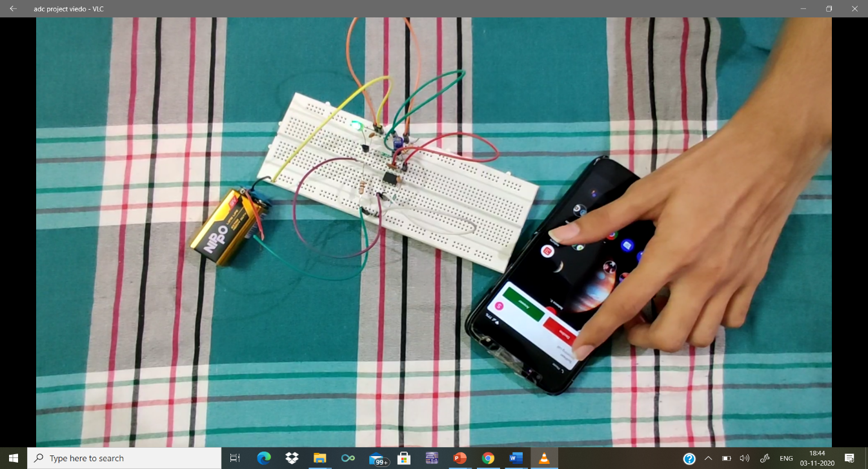

**Components used are:**

* CA3130 Op-Amp
* BC548 Transistor
* RESISTORS -2.2M ohm,100K ohm, 1K ohm
* CAPACITOR -0.22uf, 47pf ,100uf (Electrolytic)
* Power supply -9v
* LED
* 9V Battery
* PCB
* **CA3130 Op-Amp :**

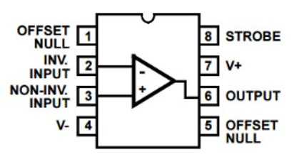

* The CA3130 are op amps that combine the advantage of both CMOS and bipolar transistors.
* Gate-protected P-Channel MOSFET (PMOS) transistors are used in the input circuit to provide very-high-input impedance, very-low-input current, and exceptional speed performance.
* The use of PMOS transistors in the input stage results in common-mode input-voltage capability down to 0.5V below the negative-supply terminal, an important attribute in single-supply applications.
* In Mobile detection,  CA3130 op amp is wired as an inverting amplifier with high gain.
* The Op-amp part of the circuit acts as the RF Signal Detector while Transistor part of the circuit act as the indicator.
* The capacitor is used to detect RF Signals when a cell phone makes (or receives) a phone call or sends (or receives) a text message.
* Op-Amp reads the signals by converting the rise in current at input to voltage at output and the LED will be activated.
* Here we will be having very low change in voltage around in mV so we will use CA3130 which can give very quick response.

**BC-548 transistor :**

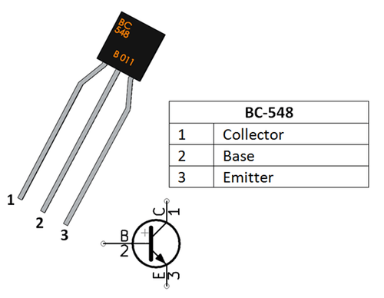

* The **BC548** is a general-purpose NPN bipolar junction **transistor.**

|  |  |  |
| --- | --- | --- |
| **Pin Number** | **Pin Name** | **Description** |
| 1 | Collector | Current flows in through collector |
| 2 | Base | Controls the biasing of transistor |
| 3 | Emitter | Current Drains out through emitter |

* Bi-Polar NPN Transistor
* DC Current Gain (hFE) is 800 maximum
* Continuous Collector current (IC) is 500mA
* Emitter Base Voltage (VBE) is 5V
* Base Current(IB) is 5mA maximum
* Available in To-92 Package
* In the circuit this bc548 is used as a switch as the base is connected to the output of the op-amp with 2.2M ohm resistor which causes very low current so when we have the output the current reaches the saturated region and this acts a switch.

**Resistors :**

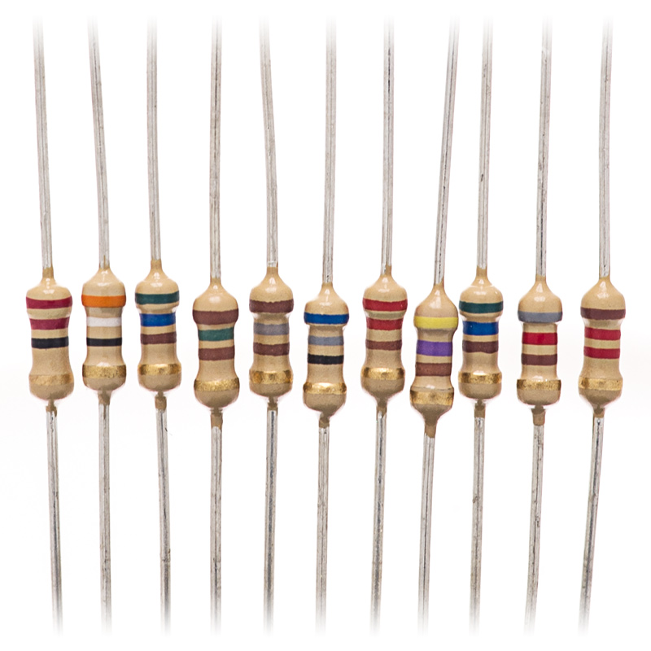

* Resistors are common elements of electrical networks and electronic circuits and are ubiquitous in electronic equipment.
* Practical resistors as discrete components can be composed of various compounds and forms. Resistors are also implemented within integrated circuits.
* Op-amp non-inverting end is connected to Vcc through 2.2M resistor and it is also connected to the ground through 100K resistor.
* Its **inverting terminal is feedback** from its output through a 2.2M resistor for amplify the signal.
* Resistors are used at the non-inverting terminal to make the voltage stable.
* Output of this op-amp is connected at the base of NPN transistor namely BC548 through a 1k resistor and a LED is connected at its emitter for indication.

**Capacitors :**

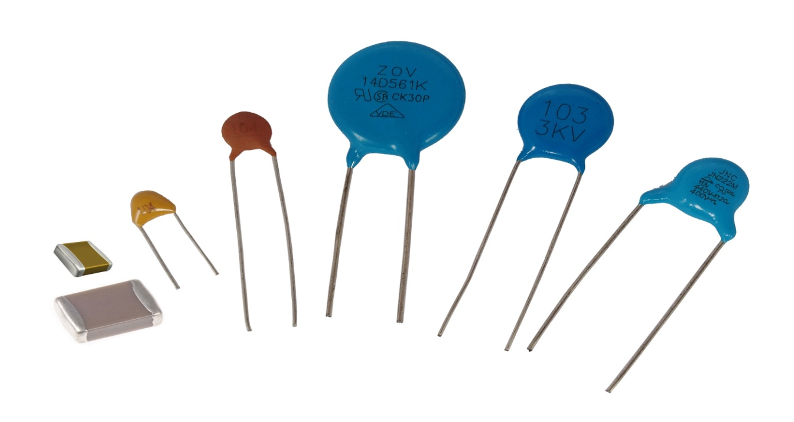

* The circuit uses a 0.22μF disk capacitor to capture the RF signals from the mobile phone.
* This part should be like an aerial, so the capacitor is arranged as a mini loop aerial.
* In short with this arrangement the capacitor works like an air core with ability to oscillate and discharge current.
* Op-amp non-inverting end is connected to Vcc through 2.2M resistor and it is also connected to the ground through 100uF Capacitor.
* In CA3130 op-amp is we connected 47pf capacitor for pin 1 and 8 so we get high gain. It provides very high input impedance and high speed performance to detect RF signals detected by the capacitor and produce output.

**LED :**



LED (Light Emitting Diode) is a semiconductor light source that emits light when current flows through it. Electrons in the semiconductor recombine with electron holes, releasing energy in the form of photons. The color of the light (corresponding to the energy of the photons) is determined by the energy required for electrons to cross the band gap of the semiconductor. White light is obtained by using multiple semiconductors or a layer of light-emitting phosphor on the semiconductor device.

**9V Battery :**

## 

## The battery has both terminals in a snap connector on one end.

## The smaller circular (male) terminal is positive, and the larger hexagonal or octagonal (female) terminal is the negative contact.

## The connectors on the battery are the same as on the load device.

## The smaller one connects to the larger one and vice versa.

## Battery polarization is normally obvious, since mechanical connection is usually only possible in one configuration.

## In this mobile detection, a 9 volt battery is used for powering the circuit.

## Applications of mobile detector:

## This circuit can be used at examination halls, meetings to detect presence of active mobiles and prevent the use of them

## It can be used for detecting mobile phones used for spying and unauthorized transmission of data

## Advantages of Mobile Detection :

## Using this we can easily detect cell phones in range of 0.5m to 0.8m. It has a good sensitivity to detect faster signals.

## We can detect incoming-outgoing calls, SMS and data Transmission even if the mobile is in silent.

## Limitations in Mobile Detection circuit :

## It has very low range in the order of centimeters.

## This being a basic model we may not detect all range of mobile signals.

## CONCLUSION

## Future scope for the project

## Tying to increase the detection range to few more meters for observing wide range of area

## With this device we can even cascade a jammer and make it an automated device to jam the signals when it finds any.

## This pocket size mobile transmission detector can sense the presence of an activated mobile phone from a distance of half meters

## So it can be used to prevent use of phones in the examination halls and confidential rooms etc..

## Reference link

## 